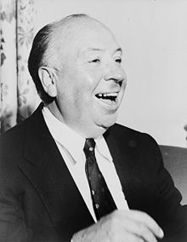

Childhood and youth
Alfred Hitchcock was born on August 13, 1899, in London, the second son and youngest of three children of William Hitchcock (1862-1914), a greengrocer and poulterer, and his wife, Emma Jane Hitchcock (1863-1942). He often described his childhood as being lonely.
When Hitchcock was 14, his father died.

Pre-War British career
In 1926 Hitchcock made his debut in the thriller genre. The resulting film, The Lodger: A Story of the London Fog was a major commercial and critical success in January 1927. On December 2, 1926, he married his assistant director Alma Reville. Their daughter Patricia was born in 1928. Alma was Hitchcock's closest collaborator. She wrote some of his screenplays and worked with him on every one of his films.
By the end of the 1930s, Hitchcock was at the top of his game artistically. It was at that time that he was convinced to move to Hollywood.

Hollywood
Hitchcock was quickly impressed with the superior resources of the American studios compared to the financial restrictions he had frequently experienced in England. Nevertheless, Hitchcock's love for his homeland resulted in numerous American films set in, or filmed in, the United Kingdom. In 1940, Hitchcock made his first American movie, although it was set in England and based on a novel by English author Daphne du Maurier. It won the Academy Award for Best Picture of 1940.
Hitchcock's second American film, the European-set thriller Foreign Correspondent was also nominated for Best Picture that year. It was filmed in the first year of World War II and inspired by the rapidly-changing events in Europe, as covered by an American newspaper reporter.
Suspicion (1941) marked Hitchcock's first film as a producer as well as director.
Are also recognized as among his very best films: Psycho (1960), and The Birds (1963).

Knighthood
Hitchcock was made a Knight Commander of the Order of the British Empire by Queen Elizabeth II in 1980. Despite the brief period between his knighthood and death, he was nevertheless entitled to be known as Sir Alfred Hitchcock .

Death
Alfred Hitchcock died at the age of 80. His body was cremated and the ashes scattered over the Pacific.

